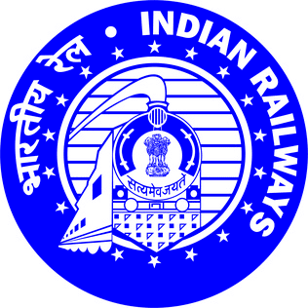

**A REPORT ON MAINTENANCE, OVERHAULING AND FAILURE ANALYSIS OF AIR COMPRESSOR USED IN ALCO & HHP LOCOMOTIVE**

**Under the guidance of**

**MR. Nareshwar Barman**

**SSE / IC / Air Compressor**

**New Guwahati Diesel Loco Shed, N.F. Railway**

**SUBMITTED BY:**

**Bishal Das**

**Padmanav Kakati**

**Bikash Kalita**

**Syed Rehab Tanjir**



**Department of Mechanical Engineering**

**NATIONAL INSTITUTE OF TECHNOLOGY, SILCHAR**

**CERTIFICATE OF APPROVAL**

***This training project entitled “ MAINTENANCE, OVERHAULING AND FAILURE ANALYSIS OF AIR COMPRESSOR” is hereby approved as a creditable study of an engineering subject carried out by Bishal Das , Syed Rehab Tanjir , Padmanav Kakati, Bikash Kalita , students of mechanical engineering, NIT Silchar . The internship period was for 6 weeks.***

***It is understood by this approval that the undersigned does not endorse or approve any statement made, opinion express or conclusion drawn therein, but approve the report only for the purpose for which it has been submitted.***

***Dated:***

***- Mr MATHURA SHARMA***

***Sr. Instructor STC/M/NGC***

***North East Frontier Railway***

***New Guwahati***

**Acknowledgement**

We take the privilege to thank SR. DME/NGC, for giving us the opportunity to undergo our industrial training in the Diesel Loco Shed of North East Frontier Railway at New Guwahati.

At training school, our mentor was Mr. Mathura Sharma, Sr. Instructor DTTC/NGC who affably taught us along each and every step and helped us in grasping a preliminary knowledge on locomotive systems. We would like to thank Mr. Nareshwar Barman, SSE / IC / Air Compressor, for imparting us with his invaluable knowledge and advice throughout the duration of training.

Last but not the least, we are very thankful to Ahmed Hussain Sir and all the technical staff of the Diesel Locomotive Shed, N.F. Railway, New Guwahati without whose support it would have not been possible for us to complete this summer training and formulate this project report.

1. Bishal Das

2. Bikash Kalita

3. Padmanav Kakati

4. Syed Rehab Tanjir

**LIST OF CONTENTS**

1. Introduction

* History of Indian railway
* Introduction to Indian Railways

2. Locomotives and classifications

3. Air compressors in diesel locomotives

4. Description of compressor parts

5.Some special systems of ALCo and HHP

6.Working of Elgi upgraded air compressor model “RR80101”(ALCO)

7. Working of Elgi air compressor model “RR66101W”(HHP)

8. Maintenance and overhauling of air compressor

* Material replacement pattern
* Tools used in maintenance practice for components

9. Overhauling of air compressor

* Removing the compressor from the locomotive
* Removal of couplings

10. Failure analysis

11.Modifications for air compressor of both ALCO and HHP for improvement

12. Conclusion

**Introduction**

**History of Indian railway**

Indian Railways has a rich history that dates back to the mid-19th century. The first train in India ran in 1853 between Bombay (now Mumbai) and Thane. Initially constructed by private companies under British colonial rule, the railway network gradually expanded, connecting major cities and ports. In 1951, after India gained independence, the Indian Railways was nationalized, leading to further growth and modernization. The organization introduced new train services like the Rajdhani Express and the Shatabdi Express, improving passenger travel. In recent years, Indian Railways has focused on infrastructure development, adopting advanced technologies, and incorporating greener initiatives. It is now one of the largest rail networks globally, playing a crucial role in the transportation of passengers and goods across the country, contributing to India's overall development.

Indian Railways has a long and eventful history. The railways in India began in the 19th century, with the first train running between Bombay and Thane in 1853. Over time, the network expanded rapidly, connecting various parts of the country and serving the interests of the British administration. After India gained independence, the railways were nationalized in 1951, leading to significant expansion and modernization. The introduction of faster and more comfortable trains, along with improvements in freight transportation, has transformed the Indian Railways into one of the largest rail networks in the world. Today, the organization continues to focus on infrastructure development, technological advancements, and sustainable practices, ensuring efficient and reliable transportation services for passengers and goods throughout India.

**Introduction to N F railway**

The NF Railway, also known as the Northeast Frontier Railway, is a crucial lifeline for the northeastern region of India. Established in 1958, it operates and manages the railway network in the states of Assam, Arunachal Pradesh, Nagaland, Manipur, Mizoram, Tripura, and parts of West Bengal and Bihar. Covering a vast geographical area, the NF Railway connects major cities and towns in this challenging terrain, facilitating the movement of passengers and goods. It is known for its scenic routes, such as the Lumding-Silchar section, and is home to notable heritage railways like the Darjeeling Himalayan Railway. With a focus on development and modernization, the NF Railway has been involved in gauge conversion projects, constructing new railway lines, and enhancing operational efficiency to promote trade, tourism, and socio-economic growth in the region.

The NF Railway's significance lies in its ability to connect remote regions of the northeastern states with the rest of India. It serves as a vital transportation link for the people living in these areas, offering improved accessibility and connectivity to major centers like Guwahati, Siliguri, Dibrugarh, Dimapur, Agartala, and Shillong. Moreover, the railway's efforts in gauge conversion from meter gauge to broad gauge have resulted in faster and smoother train operations, benefiting both passengers and the movement of goods. The presence of heritage railways within the NF Railway network, such as the iconic Darjeeling Himalayan Railway, adds to its charm, attracting tourists from around the world. Additionally, the railway's infrastructure development projects, including the construction of new lines, track doubling, and electrification, contribute to the overall growth of the northeastern region by promoting trade, facilitating the movement of agricultural and industrial goods, and supporting the thriving tourism industry.

In summary, the NF Railway plays a vital role in the socio-economic development of the northeastern region of India. Through its extensive network, it connects remote areas, enhances accessibility, and enables the movement of passengers and goods. The railway's commitment to development and modernization, coupled with its focus on gauge conversion and heritage railways, contributes to the region's trade, tourism, and overall growth. As a lifeline for the northeastern states, the NF Railway serves as a significant catalyst for connectivity, economic progress, and cultural exchange between this region and the rest of the country.

Few major sections under the Northeast Frontier railway zones are:

* New Bongaigaon-Guwahati section.
* Rangia-Murkongselek section.
* Guwahati-Lumding section
* Lumding-Dibrugarh section
* Lumding- Silchar section.
* Silchar-sabroom section.

**Locomotives and classifications:**

* Diesel locomotives: These are the most common type of locomotive in use today. They are powered by a diesel engine, which turns a generator that produces electricity. The electricity is then used to power the locomotive's traction motors, which turn the wheels.
* Electric locomotives: These locomotives are powered by electricity, which is either stored on board the locomotive in batteries or retrieved from overhead wires. Electric locomotives are more efficient than diesel locomotives, but they require a more complex infrastructure to operate.
* Steam locomotives: Steam locomotives were the first type of locomotive, and they were used for many years until they were replaced by diesel and electric locomotives. Steam locomotives are powered by burning coal or oil to heat water, which turns into steam. The steam is then used to power the locomotive's pistons, which turn the wheels.

Locomotives are used to pull trains of cars, which can carry passengers or freight. They are an essential part of the transportation system, and they play a vital role in moving goods and people around the world.

**Air compressors in diesel locomotives:**

Air compressors are machines that take in air and compress it, increasing its pressure. They are used in a variety of applications in train locomotives, including:

* Powering pneumatic circuits: Pneumatic tools are powered by compressed air. Air compressors can be used to power a variety of circuit breakers which are used in electric applications of locomotives like the governor circuit etc..
* Breaking system:The compressed air is stored in a reservoir and is released when the brake valve is operated. The brake valve is typically located in the cab of the locomotive. The compressed air is then used to operate the brake cylinders, which apply the brakes on the wheels of the locomotive.
* Horn:The horn in a diesel locomotive is operated by compressed air. When the engineer presses the horn button, a valve opens and allows compressed air to flow into the horn. The compressed air then vibrates a diaphragm, which produces sound waves. The sound waves are amplified by the horn's bell, and the horn produces a loud noise.

So,the air compressor in a diesel locomotive is a vital component that provides the compressed air needed for the train's brakes, horns, and other pneumatic systems.The air compressor in a diesel locomotive is a critical safety system. It is important to regularly inspect and maintain the system to ensure that it is working properly.

Here we discussed about the two diesel locomotive air compressors below with history and specifications-

**American locomotive company(ALCo) locomotive air compressor**:The ALCO RR80101 air compressor is a two-stage, air-cooled compressor that uses a reciprocating piston to compress air. It has a maximum pressure of 100 psi and a capacity of 100 Square Cubic Feet Per Minute. The compressor is driven by the engine.

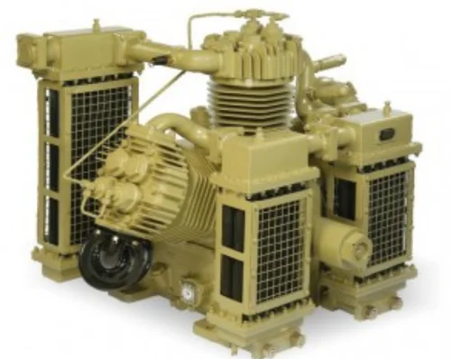

ALCO RR80101 air compressor

The ALCO RR80101 air compressor was used in a variety of ALCO locomotives. It is also used in other industrial applications, such as air brakes and pneumatic tools.

The ALCO RR80101 air compressor is a reliable and durable compressor that is well-suited for use in demanding applications. It is easy to maintain and repair, and it has a long lifespan.

Here are some of the features of the ALCO RR80101 air compressor:

* Two-stage compression
* Air-cooled
* Reciprocating piston
* Maximum pressure of 100 psi
* Capacity of 100 SCFM
* Easy to maintain and repair
* Long lifespan

If you are looking for a reliable and durable air compressor for use in demanding applications, the ALCO RR80101 air compressor is a good option.

**High horsepower(HHP) locomotive air compressor**:The HHP RR66101W air compressor is a two-stage, air-cooled compressor that uses a reciprocating piston to compress air. It has a maximum pressure of 125 psi and a capacity of 100 Square Cubic Feet Per Minute. The compressor is driven by the engine.

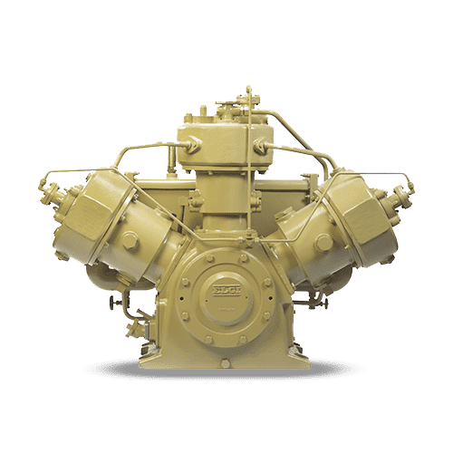

HHP RR66101W air compressor

The HHP RR66101W air compressor is designed for use in industrial applications, such as air brakes, pneumatic tools. It is a reliable and durable compressor that is well-suited for demanding applications.

Here are some of the features of the HHP RR66101W air compressor:

* Two-stage compression
* Water-cooled
* Reciprocating piston
* Maximum pressure of 125 psi
* Heavy-duty construction
* Easy to maintain and repair
* Long lifespan

If you are looking for a reliable and durable air compressor for use in demanding industrial applications, the HHP RR66101W air compressor is a good option.

Some disadvantages where we propose for improvement:

* Can be noisy
* Not as portable as some other air compressors
* Can be expensive

Overall, the HHP RR66101W air compressor is a good option for those who need a reliable and durable air compressor for use in demanding industrial applications. It is a bit noisy and not as portable as some other air compressors, but it is well-built and should last for many years.

**Description of compressor parts**

A diesel locomotive's air compressor is responsible for supplying compressed air to various systems, such as the braking system, air horns, and other pneumatic devices. Here is a description of each major part of a diesel locomotive's air compressor:

**Compressor Cylinder and head**: The compressor cylinder is the main component where the compression of air takes place. It consists of a cylinder with a piston that moves back and forth to compress the air.

Compressor is equipped with three cylinder heads along with valves.Cylinder heads are there to hold the valves at their position.

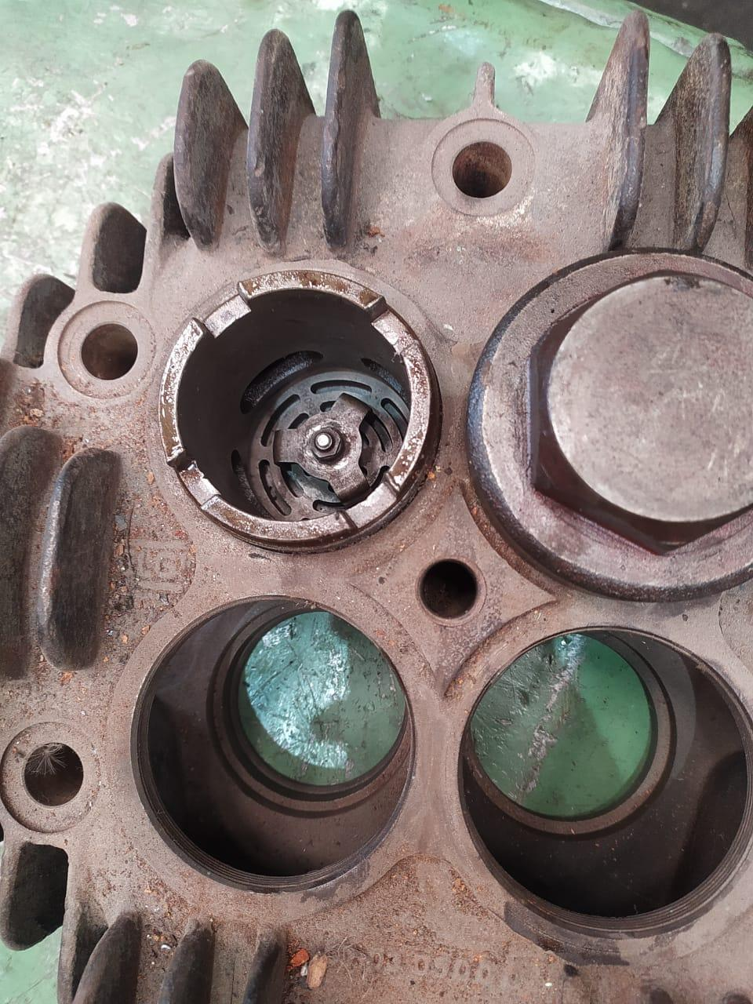

**Fig : Cylinder head**

**Piston rings**: The piston rings are fitted around the piston and ensure a tight seal between the piston and the cylinder wall. They prevent air leakage during compression.

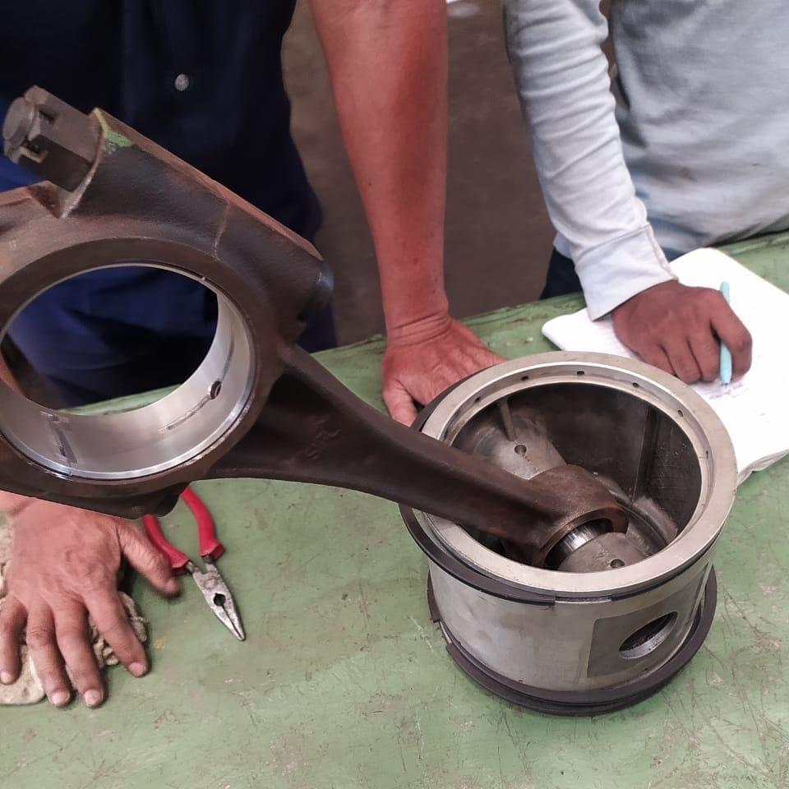

**Fig : Piston rings**

**Inlet Valve**: The intake valve allows atmospheric air to enter the cylinder during the suction stroke. It opens to let air in and closes to prevent air from escaping during compression.

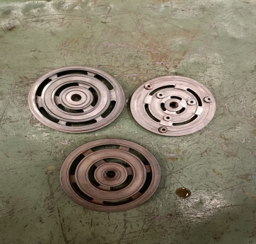

**Fig:Intake valves**

**Discharge Valve**: The discharge valve is responsible for releasing the compressed air from the cylinder to the air receiver tank or the system it supplies, through intercooler after cooling.

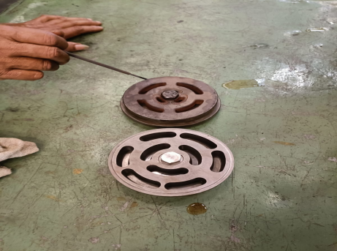

**Fig:Discharge valve**

**Crankshaft**: The crankshaft is connected to the piston and converts the reciprocating motion of the piston into rotary motion. It transfers the power generated by the piston to drive the compressor.

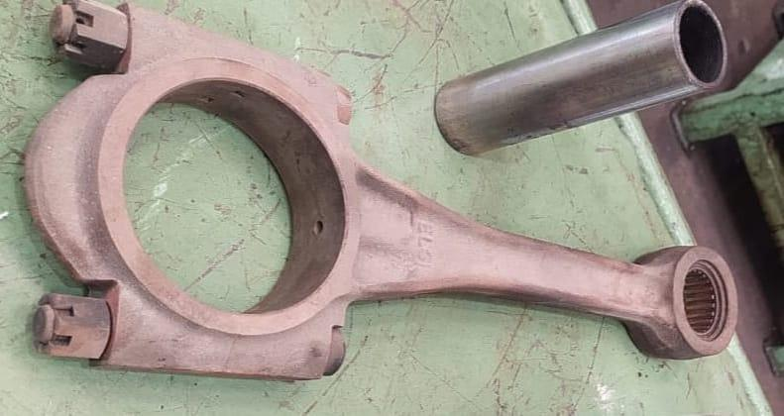

**Fig : Crankshaft**

**Compressor Piston** : The low pressure pistons are made of aluminum and elliptically ground on the outside diameter. The high pressure piston is made of cast iron. Pistons reciprocate taking the power from the connecting rod.

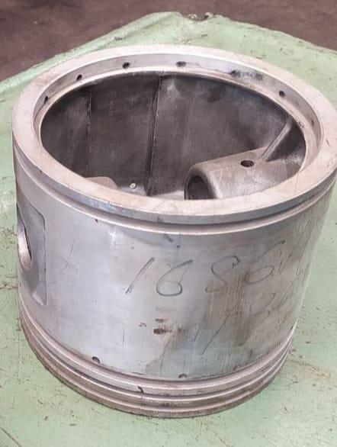

**Fig : Compressor Piston**

**Drive Gear**: The drive gear connects the crankshaft of the compressor to the engine's power source, such as the diesel engine. It transfers the rotational power from the engine to the compressor.

**Pressure relief valves**: These are an essential part of any air compressor system. They regulate and limit the buildup of pressure in a system. If the pressure exceeds the amount allowed by the pressure relief valve, the valve will automatically open and release air until the pressure decreases.

**Copper pipes**:These are used to conduct the unloading operation. When the pressure rises till the upper limit,the governor gives a signal to start the unloading and some air comes through the copper pipes to open up the inlet valve for the whole operation.

**Lube oil pump**:The lube oil pump of an air compressor is an essential component that ensures proper lubrication of the compressor's moving parts. It is responsible for circulating oil throughout the compressor system, lubricating bearings, pistons, cylinders, and other critical components. The primary function of the lube oil pump is to maintain a thin film of oil between moving parts to reduce friction, minimize wear and tear, and dissipate heat.

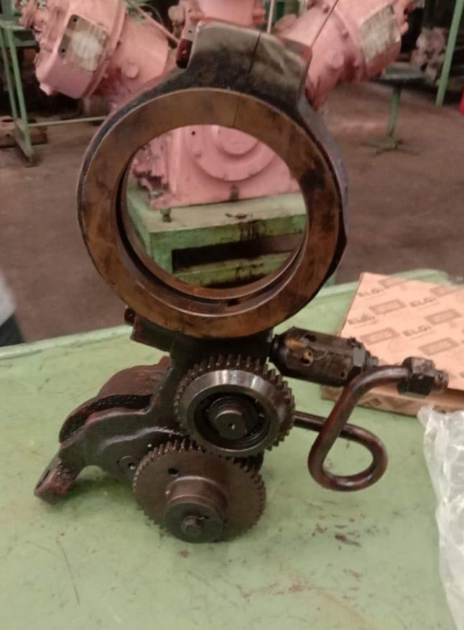

**Fig: Lube Oil pump**

**Air Filter**: The air filter removes contaminants and impurities from the intake air before it enters the compressor cylinder. It ensures clean air for compression and protects internal components from damage.

**Governor**: The governor is a control device that regulates the speed and output of the air compressor. It adjusts the compressor's operation based on the air demand and maintains a consistent pressure in the system.

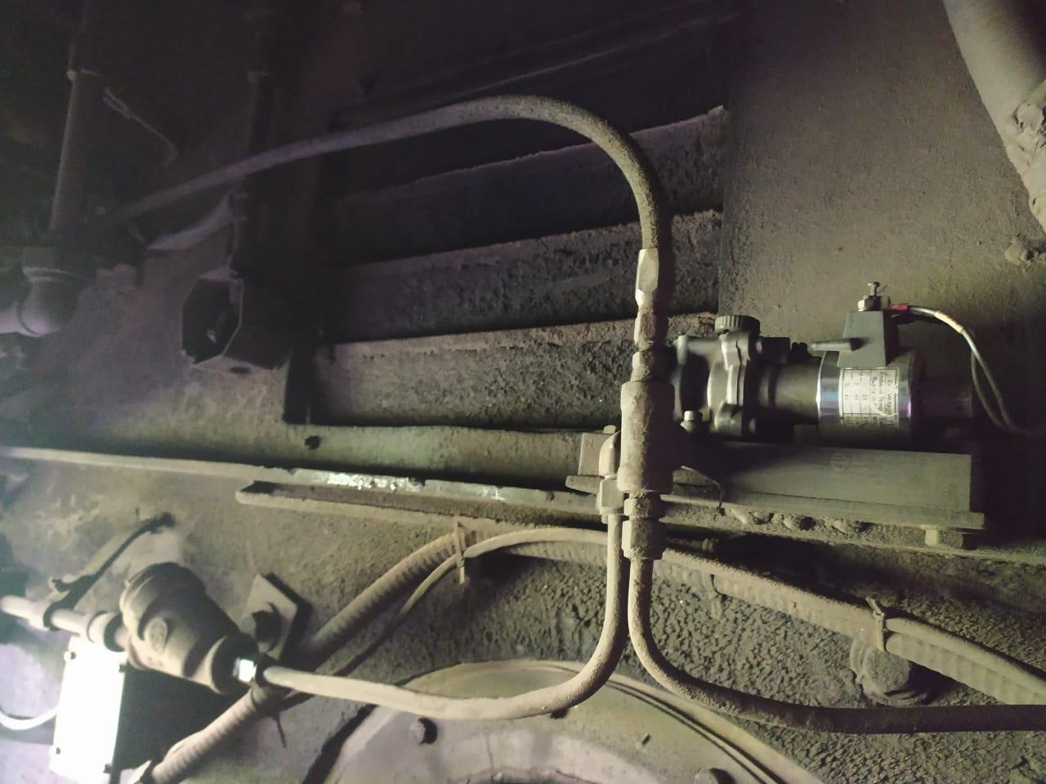

**Fig : Governor Panel**

**Breather valve**:A breather valve is a safety device that is used to prevent the buildup of pressure or vacuum in an air compressor. It is typically located on the top of the air compressor, and it allows air to flow in and out of the compressor as needed.

**Intercooler**:The intercooler in a diesel locomotive compressor is a heat exchanger that is used to cool the air that is compressed by the compressor. The intercooler is typically located between the low pressure cylinder(LP) and high pressure cylinder(HP).

**Aftercooler**:An aftercooler in a compressor of a diesel locomotive is a heat exchanger that is used to cool the air that is compressed by the compressor after it has passed through the intercooler. The aftercooler is typically located between the High Pressure cylinder(HP) and the air reservoir.

These are the major components of a diesel locomotive's air compressor. Each part plays a crucial role in compressing air and ensuring the efficient operation of the locomotive's pneumatic systems.

**Difference between HHP and Alco air compressor**

| Feature | HHP Compressor | Alco Compressor |
| --- | --- | --- |
| Efficiency | More efficient | Less efficient |
| Heat pump optimized | Yes | No |
| Reed valve | Yes | No |
| Low sound level | Yes | No |
| Extended operating envelope | Yes | No |
|  |  |  |

**Some special systems of ALCO and HHP**

**Water cooled system**::A water-cooled system in a railway air compressor is a cooling mechanism used to dissipate heat generated during the compression process.

Compressing air generates heat due to the compression process, and if left unchecked, this heat can damage the compressor and affect its performance. To prevent overheating, a water-cooled system is employed to remove the excess heat and maintain optimal operating temperatures.

To cool the compressor the water pump circulates the water to low pressure cylinders of both sides of compressor and to high pressure cylinder. While water pumping to low pressure cylinder an intermediate connection will be there to the intercooler. Water which passes through intercooler helps to cool the high pressurized air.In low pressure cylinder the water enters to low pressure liners to head of the cylinder and in the same the water enters to high cylinder.The water in compressor at last is collected at high pressure cylinder head from there it flows to oil cooler to radiator.

Overall, the integration of a water-cooled system in a railway air compressor helps maintain optimal operating temperatures, prolong the compressor's lifespan, and ensure reliable performance in demanding railway applications.

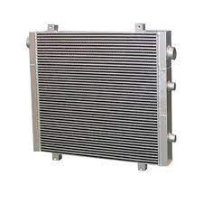

Fig : Radiator

**Lubrication system of diesel locomotive air compressors:**The lubrication system of a compressor is essential for its proper operation. It helps to reduce friction between the moving parts, which minimizes wear and tear and helps to keep the compressor running smoothly. It also helps to remove heat from the moving parts, which helps to prevent them from overheating.

The lubrication system of a compressor typically consists of the following components:

* Crankcase The crankcase is a reservoir that holds the lubricating oil.
* Pressure pump The pressure pump draws oil from the crankcase and pumps it under pressure to the bearings and other moving parts of the compressor.
* Strainer The strainer removes any impurities from the oil before it is pumped to the bearings.
* Filter The filter further cleans the oil to remove any remaining impurities.
* Cylinder lubricator The cylinder lubricator supplies oil to the cylinder walls to help prevent them from overheating.

The lubrication system of a compressor is an important part of the overall design of the compressor. It helps to ensure that the compressor operates efficiently and reliably.

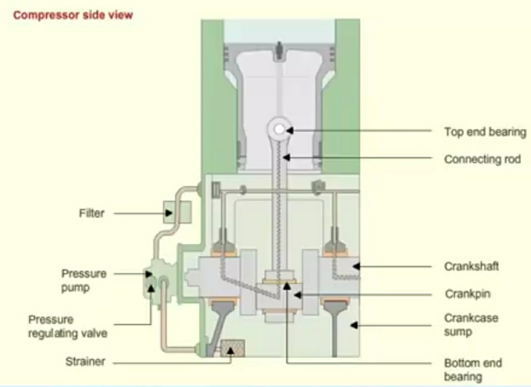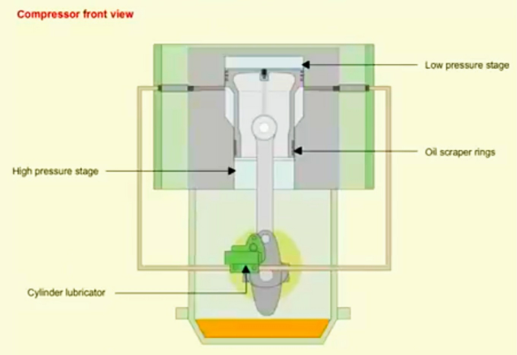

Fig : components of lubrication system of an air compressor

Here are some additional details about the lubrication system of a compressor:

* The lubricating oil used in a compressor must be compatible with the materials used in the compressor.
* The oil level in the crankcase must be kept at the proper level.
* The oil filter must be replaced regularly.
* The cylinder lubricator must be adjusted to provide the correct amount of oil to the cylinder walls.

By following these guidelines, you can help to ensure that the lubrication system of your compressor operates properly and helps to keep your compressor running smoothly and efficiently.

Here are some additional details about the lubrication system of the compressor described in the text:

* The lubricating oil is drawn from the crankcase through a strainer and delivered to the bearings through a fine filter.
* A pressure regulating valve is provided on the delivery side, which maintains the lube oil pressure.
* The oil flows from the bearing to the crankpin through the holes in the crankshaft journals.
* From the crankpin, the oil then flows to the bottom end bearing of the connecting rod. Through the connecting rod, the oil reaches the top end bearing.
* A cylinder lubricator on the free end of the crankshaft supplies oil to the low pressure stage cylinder through the lubricator quills.
* The oil scraper ring controls the cylinder lubrication in the high pressure stage.

**Working of Elgi upgraded air compressor model “RR80101”(alco)**

The Elgi upgraded air compressor model “RR80101” is a portable, oil-less air compressor that is ideal for workshop use. It has a maximum air pressure of 80 PSI and a maximum air flow of 10 CFM, making it suitable for a variety of tasks, such as braking, powering pneumatic tools, and horn system.

The air compressor is typically driven by the locomotive’s prime mover,which is a diesel engine. The crankshaft and a gearing system is there to transmit energy from the diesel engine to the compressor pistons.

Here is a brief overview of how the Elgi upgraded air compressor model “RR80101” works:

1. Power Source: The air compressor is connected to the locomotive's diesel engine through a mechanical linkage. As the diesel engine runs, it drives the air compressor.
2. Intake Stroke: The air compressor has an intake valve that opens, allowing atmospheric air to enter the cylinder. During this stroke, the piston moves downward, creating a vacuum inside the cylinder.
3. Compression Stroke: The intake valve closes, and the piston moves upward, compressing the air within the cylinder. This compression raises the air pressure.

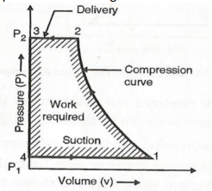

**P-V diagram of compressor cycle**

1. Discharge Stroke: Once the compressed air reaches a predetermined pressure, the discharge valve opens, allowing the compressed air to be pushed out of the cylinder into an air reservoir or receiver. The piston moves downward during this stroke.
2. Cooling: To prevent the air compressor from overheating, it is typically equipped with a cooling system. This can include fans, air ducts, and cooling fins to dissipate heat generated during compression.
3. Repeat Cycle: The process of intake, compression, and discharge is repeated continuously as long as the locomotive's engine is running and there is a demand for compressed air.

Here, the working of an ALCO locomotive air compressor is explained briefly.

**Working of Elgi air compressor model “RR66101W”(HHP)**

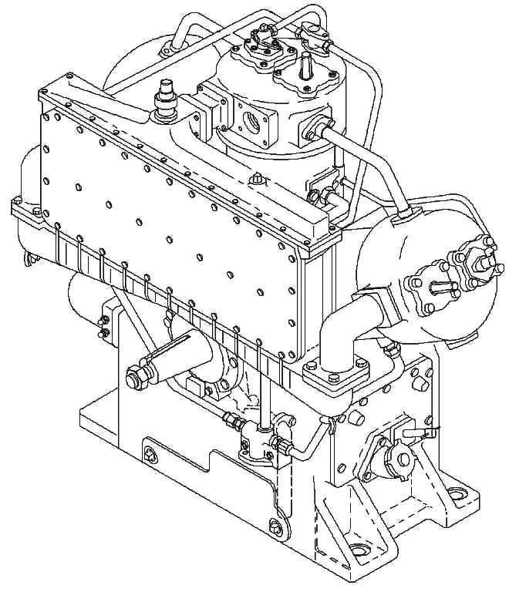

Diagram of HHP air compressor

"W-type configuration, three cylinder, two-stage, forced lubrication, water-cooled and direct coupled" refers to a type of air compressor that is characterized by its compact design, efficient compression process, and high output of compressed air.

The air compressor in an HHP locomotive is a complex system, but it is essential for safely operating the locomotive. The system is designed to provide a smooth and controlled flow of compressed air, even when the locomotive is moving at high speeds.

The working of HHP air compressor is described below:

1. The air is drawn into the compressor through an air filter.
2. The air is compressed in the first stage of the compressor.
3. The compressed air is then passed through an intercooler to cool it down.
4. The compressed air is then compressed in the second stage of the compressor.
5. The compressed air is then stored in an air reservoir passing through delivery pipes.

These are the 5 steps of working of HHP air compressors.

**Maintenance of air compressor**

The importance of maintenance in diesel locomotives cannot be overstated. Diesel locomotives are complex machines that require regular maintenance to keep them running safely and efficiently.

It is important to follow a regular maintenance schedule for your diesel locomotive. The specific schedule will vary depending on the locomotive's age, condition, and the type of work that it is used for. However, most locomotives should be inspected and maintained.

The maintenance of compressor parts are divided and explained below:

**Material Replacement Pattern:**

There are two types of material replacement pattern-

1. Must changing item
2. Checking Item

1. Must changing item:

Under this pattern, certain materials are unquestionably replaced after a specific duration, regardless of their condition (whether they are in good or bad condition). At NGC Diesel Shed, these replacements occur at fixed intervals of 12 months, 24 months, and 48 months. These replacements are obligatory and follow a schedule known as M-12, M-24, and M-48, respectively.

2. Checking Items:

In this replacement pattern, materials are replaced only when they are found to be defective or unsuitable during regular inspections. Unlike the mandatory replacements, there is no predetermined time frame for these replacements. Instead, they are changed as soon as they are identified as defective during inspections. As a result, these materials are referred to as checking items since they are replaced based on inspection findings and not on a predefined schedule.

**Replacement of must change item during schedule attention:**

In NGC Diesel Shed, there are 100 must-change items that follow three different types of replacement schedules:

1. M-12: These items are changed every 12 months.

2. M-24: These items are changed every 24 months.

3. M-48: These items are changed every 48 months.

During the scheduled maintenance intervals, all 100 must-change items are replaced according to their respective schedules.

| **M-12** | **M-24/ M-48** |
| --- | --- |
| Lube oil | Low pressure liner |
| Flange gasket | High pressure liner |
| Indicator gasket | Low pressure piston |
| Side cover gasket | Bearing conrod |
| Gasket cylinder (bottom) | Air intake filter |
| Rubber block | Lube oil pump assembly |
| 1⁄2" armored gasket  1" armored gasket | Rubber block  Safety valve |
|  | Oil seal |
|  | Unloader body with cap and valve |
|  | Oil relief valve assembly |
|  | Crankcase vacuum main valve |
|  | Lube oil (strainer "o" ring) |

**Tools used in maintenance practice for components:**

There are multiple tools employed in the machining practice for each component. These tools include:

1. Outside micrometer (available in various sizes)

2. Inside micrometer (available in various sizes)

3. Dial indicator

4. Bore gauge

5. Torque meter

6. Compressor valve testing unit

7. Pipe wrench

8. Table vices

9. Block unit testing stand

10. Lapping machine

These tools are utilized to test and rectify the components of the compressor. Every year, a government inspector assigned by INDIAN RAILWAYS examines these maintenance tools to ensure their accuracy. Consequently, the calibration of these tools is carried out annually.

**Overhauling of air compressors**

An overhaul is a complete inspection, cleaning, and repair of a machine, or here the compressor equipment. It is a more extensive process than regular maintenance, and it is typically performed when the equipment is showing signs of wear and tear or after a very long period (in case of alco and HHP it is almost after three years).

The process of overhaul is described below in detailed manner:

**Removing the compressor from the locomotive**

Apply locomotive handbrake or parking brake. All power to the compressor is to be cut-off.Wheel chocks are to be applied to the wheels to prevent the vehicle movement.Transport the removed compressor to the shop area for maintenance.The mounting base shims in their respective positions,preferably by wiring them in place if the same compressor is to be reinstalled in the same locomotive from which it is removed.

Installation of an overhauled replacement compressor should be done in reverse order of removal following locomotive builder locomotive instructions.

**Removal of couplings**

After removing from the locomotive the compressor components are removed one by one which explained briefly:

* **Remove the crankshaft lock nut.The clamping screws in on the coupling are removed for facilitating the removal of fan from the coupling half.After that the accessories such as the intercooler ,aftercooler ,air intake strainers ,piping to the governor,oil gauge,manifolds and side covers are removed.**
* **Before further disassembly the exterior surface should be cleaned.Parts should be marked so that it could assemble at proper order**

**.**

* **Remove the drain plug at bottom of the crankcase to drain the oil.**
* **Remove the intercooler and aftercooler safety valves.**

**Remove the screws or bolts**: Use a screwdriver or wrench to remove the screws or bolts that hold the safety valves in place. Be careful not to lose the screws or bolts.

**Remove the safety valves**: Once the screws or bolts are removed, the safety valves can be lifted off. Be careful not to damage the safety valves.

**Inspect the safety valves**: Once the safety valves are removed, you can inspect them for any signs of wear or damage. You can also clean the safety valves if needed.

**Replace the safety valves:** When you are finished inspecting the safety valves, you can replace them. Make sure that the screws or bolts are tightened securely.

* **Remove the oil level float gage;remove the gage before removing the side cover to prevent damage to the float lever.**

**Locate the oil level float gauge:** The oil level float gauge is typically located on the side of the air compressor. It is a small, clear tube with a float inside.

**Remove the float gauge**: To remove the float gauge, you will need to loosen the screws or bolts that hold it in place. Once the screws or bolts are loose, you can gently pull the float gauge out of the air compressor.

**Be careful not to damage the float lever**: The float lever is a small, metal rod that is connected to the float. It is important to be careful not to damage the float lever when you are removing the float gauge.

**Replace the float gauge:** When you are finished removing the float gauge, you can replace it by reversing the steps above. Make sure that the screws or bolts are tightened securely.

Here are some additional information for removing the oil level float gauge:

1)If the float gauge is stuck, you can try using a lubricant to help loosen it.

2)If the screws or bolts are rusty, you can use a penetrating oil to help loosen them.

3)Be careful not to overtighten the screws or bolts when you replace the float gauge.

* **Remove side covers**.

**Locate the side covers**: The side covers are typically located on the sides of the air compressor. They are usually held in place by screws or bolts.

**Remove the screws or bolts**: Use a screwdriver or wrench to remove the screws or bolts that hold the side covers in place. Be careful not to lose the screws or bolts.

**Remove the side covers**: Once the screws or bolts are removed, the side covers can be lifted off. Be careful not to damage the side covers.

* **Removing air filters, crankcase breather.**

To remove an air filter, simply unscrew the retaining nuts or bolts that hold it in place. Once the filter is removed, inspect it for any signs of damage or contamination. If the filter is dirty or damaged, it should be replaced.

To remove a crankcase breather, locate the breather hose that connects to the engine. Disconnect the hose from the engine and then remove the breather filter from the hose. Inspect the filter for any signs of damage or contamination. If the filter is dirty or damaged, it should be replaced.

* **Remove the intercooler and aftercooler**

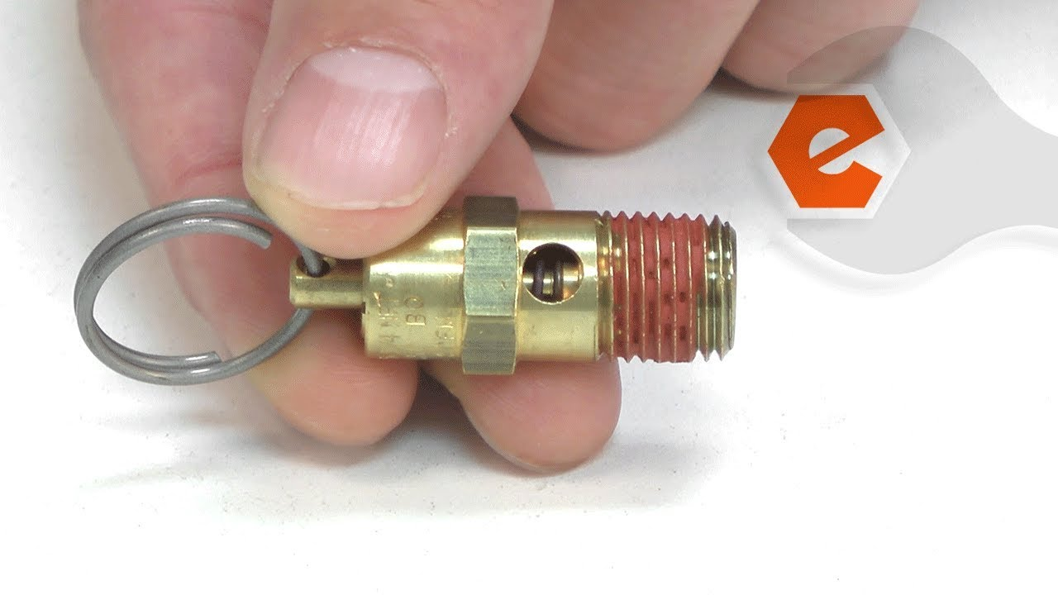

**Remove the intercooler and aftercooler**: Once the screws or bolts are removed, the intercooler and aftercooler can be lifted off. Be careful not to damage the intercooler or aftercooler.

**Inspect the intercooler and aftercooler:** Once the intercooler and aftercooler are removed, you can inspect them for any signs of wear or damage. You can also clean the intercooler and aftercooler if needed.

**Replace the intercooler and aftercooler**: When you are finished inspecting the intercooler and aftercooler, you can replace them. Make sure that the screws or bolts are tightened securely.

**.**

* **Remove cylinder head assembly and cylinders.**

1)Remove the piston assembly from the connecting rod wrist pin end by removing the wrist pin.

2)Locate the wrist pin. The wrist pin is a small, cylindrical pin that connects the piston to the connecting rod. It is usually located in the center of the piston.

3)Remove the snap rings. The snap rings are small, metal rings that hold the wrist pin in place. They are usually located on either side of the wrist pin.

4)Use a punch or drift to drive out the wrist pin. Be careful not to damage the piston or the connecting rod.

5)Once the wrist pin is removed, the piston assembly can be lifted off of the connecting rod.

* **Remove the oil pump assembly from the crankcase,Remove the oil seal.**

1. Support the crankshaft with appropriate equipment. Remove end cover bolts and pull end cover off the crankcase.
2. Support the crankshaft with a suitable lifting device. This will prevent the crankshaft from rotating when you remove the end cover bolts.
3. Remove the end cover bolts. There are usually four or six end cover bolts, and they are typically located on the side of the crankcase.
4. Pull the end cover off the crankcase. Be careful not to damage the end cover or the crankshaft.

* **Remove the crankshaft from the crankcase.**
* **After that cylinder head disassembly and discharge and suction valves are done.Cylinder disassembly is done accordingly.**
* **Remove the gaskets (no wire brush or grinding tools are to be used when removing the gaskets).**
* **Remove the connecting rod caps,and then remove the connecting rod and piston assemblies.**

**Remove the connecting rod caps**: Use a socket wrench or wrench to remove the bolts or screws that hold the connecting rod caps in place. Be careful not to lose the bolts or screws.

**Remove the connecting rod and piston assemblies:** Once the connecting rod caps are removed, the connecting rod and piston assemblies can be lifted out of the cylinder block. Be careful not to damage the connecting rod or piston assemblies.

**Inspect the connecting rod and piston assemblies**: Once the connecting rod and piston assemblies are removed, you can inspect them for any signs of wear or damage. You can also clean the connecting rod and piston assemblies if needed.

**Replace the connecting rod caps and piston assemblies**: When you are finished inspecting the connecting rod and piston assemblies, you can replace them. Make sure that the bolts or screws are tightened securely.

* **Crankcase disassembly is done.**
* **The cleaning and failure analysis is done and damaged parts are replaced with the healthy ones.**
* **Now the process is done in reverse order to assemble the whole compressor.**

Overhauls can be a time-consuming and expensive process, but they can help to extend the life of equipment and prevent costly repairs.

**Failure analysis of air compressors**

Failure analysis tests for air compressors in diesel locomotives are crucial to identify the root causes of any issues or malfunctions and to develop effective solutions. Which can provide us a general outline of the failure analysis test process. It is important to note that specific tests and procedures may vary depending on the locomotive model and the manufacturer. It is always recommended to refer to the locomotive's maintenance manual for detailed instructions.

Here the tests in an air compressor in a diesel locomotive:

* **Visual inspection:**This initial step involves visually examining the failed component or area to identify any visible signs of damage, wear or anomalies.It can provide valuable insights into the nature of failure and guide further testing.
* **Non destructive testing(NDP)**:The techniques are used to evaluate the integrity of the materials and components without causing damage.The common methods include:

1. Magnetic particle testing:Magnetic particle testing (MT) is a non-destructive testing (NDT) method that uses magnetic fields to detect surface and subsurface discontinuities in ferromagnetic materials. The process involves magnetizing the part and then applying a suspension of magnetic particles to the surface. The particles will be attracted to any discontinuities in the magnetic field, creating visible indications that can be easily identified.

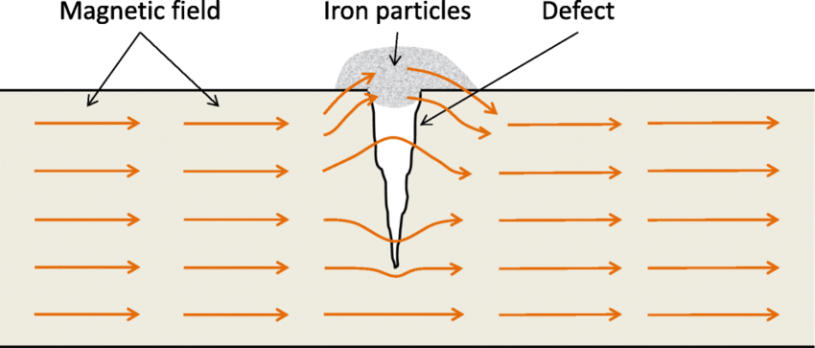

Diagram of magnetic particle testing

Here are the steps involved in magnetic particle testing:

* Magnetize the part. This can be done by passing an electric current through the part or by using an external magnetic field.
* Apply a suspension of magnetic particles to the surface. The particles are typically made of iron powder or ferromagnetic flakes.
* Inspect the surface for indications. Any discontinuities in the magnetic field will attract the magnetic particles, creating visible indications.

MT is a valuable NDT method for inspecting ferromagnetic materials. It is a simple, inexpensive, and effective method for detecting surface and subsurface discontinuities.

1. Dye penetrant testing: Dye penetrant testing (DP) is a non-destructive testing (NDT) method that is used to detect surface-breaking discontinuities in materials. The process involves applying a dye penetrant to the surface of the material, allowing it to seep into any discontinuities, and then removing the excess dye. A developer is then applied, which causes the dye to bleed out of the discontinuities, making them visible.

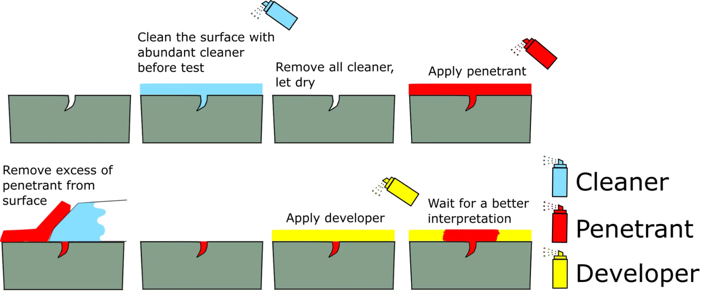

Diagram of Dye Penetrant testing

Here are the steps involved in dye penetrant testing:

* Clean the part. The part must be clean and free of dirt, oil, and grease.
* Apply the dye penetrant. The dye penetrant is typically applied by spraying or brushing.
* Allow the dye penetrant to seep into the discontinuities. This may take several minutes.
* Remove the excess dye penetrant. This is typically done by wiping the part with a clean cloth.
* Apply the developer. The developer is typically applied by spraying or brushing.
* Inspect the part for indications. Any discontinuities will appear as bright lines or areas on the surface of the part.

DP is a valuable NDT method for inspecting a wide variety of materials. It is a simple, inexpensive, and effective method for detecting surface-breaking discontinuities.etc.

Remember, the above steps provide a general framework for failure analysis tests. Always consult the locomotive manufacturer's guidelines and involve qualified technicians who are familiar with the specific locomotive model to ensure accurate and effective testing and analysis.

**Modifications for air compressor of both ALCO and HHP for improvement**

There are a few modifications that can be made to the air compressor to improve its performance or add new features.

* Add a sound dampener: The Alco is a relatively noisy air compressor, but adding a sound dampener to the compressor, will help to reduce the noise level of the compressor.
* One potential modification is to use variable speed drives (VSDs) to control the compressor's speed. VSDs can vary the compressor's speed according to the demand for compressed air.which can help to improve efficiency and reduce emissions.
* More efficient compressor designs: More efficient compressor designs can help to improve efficiency by reducing the amount of energy that is required to compress the air. This can lead to significant savings in fuel costs.

These are just a few of the recommendations for improving the performance of a diesel locomotive air compressor. By making these modifications, we can improve the performance of the compressor or add new features to make it more versatile.

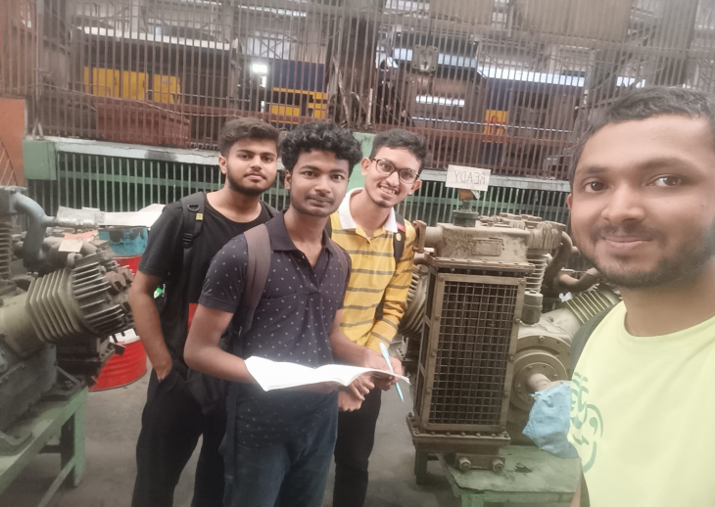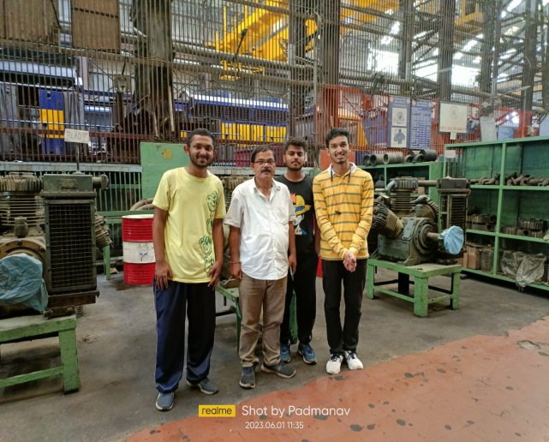

**Conclusion**

In conclusion, diesel locomotive air compressors are essential components of diesel locomotives. They provide the compressed air that is used to power the locomotive's brakes, horns, and other pneumatic devices. Air compressors are also used to provide compressed air for other purposes, such as inflating tires and cleaning surfaces.

There are a number of factors that can affect the performance of a diesel locomotive air compressor, including the size of the air tank, the power of the motor, and the type of compressor. By making modifications to the compressor, it is possible to improve its performance and extend its lifespan.

Here are some of the benefits of improving the performance of a diesel locomotive air compressor:

* Improved performance: By upgrading the motor and air tank, it is possible to improve the performance of the compressor. This can lead to increased efficiency and reduced downtime.
* Extended lifespan: By adding a pressure regulator, air filter, and sound dampener, it is possible to extend the lifespan of the compressor. This can save money on repairs and replacement costs.
* Increased safety: By making modifications to the compressor, it is possible to improve safety. For example, adding a pressure regulator can help to prevent over-pressurization, which can lead to explosions.

Overall, there are a number of benefits to improving the performance of a diesel locomotive air compressor. By making modifications to the compressor, it is possible to improve its performance, extend its lifespan, and increase safety.